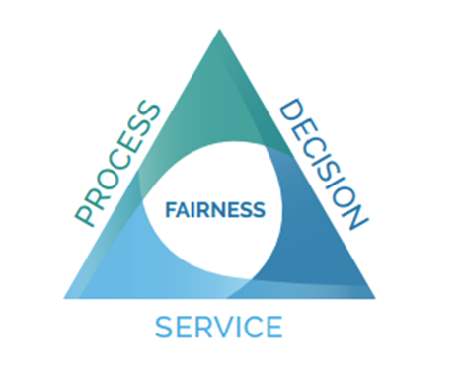

**CONTENTS INTRODUCTION**

**1. Using this Guide**

**2. What is Fairness?**

**3. Complaint Review Standards**

* Fairness in Complaint Handling
* Impartiality and Integrity
* Accessibility and Responsiveness
* Accountability in Complaint Resolution

**4. Complaint Review Checklist**

**5. Professional Client Handling Checklists**

* Case Managers
* General Staff

**INTRODUCTION**

**Using this Guide**

This guide outlines best practices for reviewing client complaints fairly, ensuring transparency and consistency. It is designed for teams dedicated to handling and resolving complaints effectively while maintaining procedural fairness and integrity.

This guide provides:

* A framework for assessing fairness in complaint resolution.
* Standards for impartiality and integrity.
* Guidelines for accessibility and responsiveness.
* Strategies for accountability and continuous improvement.

By using this guide, your organization can enhance public confidence, improve client satisfaction, and refine service delivery processes.

**WHAT IS FAIRNESS?**

Fairness in complaint review ensures:

* **Fair Process:** Clients have the right to be heard and receive clear communication regarding their complaint.
* **Fair Decision:** Complaints are assessed based on facts, policy, and applicable procedures, ensuring unbiased outcomes.
* **Fair Service:** Clients receive respectful and timely responses to their concerns.

**COMPLAINT REVIEW STANDARDS**

**1. Fairness in Complaint Handling**

To ensure procedural fairness, the complaint review process must:

* Provide clients with clear guidelines on how to file a complaint.
* Offer reasonable timelines for review and resolution.
* Ensure decisions are based on established policies and evidence.
* Communicate decisions and reasoning in an understandable manner.

**2. Impartiality and Integrity**

* Establish and enforce conflict of interest policies.
* Train complaint reviewers on unbiased decision-making.
* Ensure reviews are conducted independently of prior interactions with the client.
* Maintain professionalism and ethical conduct in all interactions.

**3. Accessibility and Responsiveness**

* Ensure multiple channels for submitting complaints (online, phone, in-person, etc.).
* Provide clear timelines for complaint resolution.
* Offer assistance for individuals who require accommodations.
* Maintain respectful and client-focused communication.

**4. Accountability in Complaint Resolution**

* Track and analyze complaints to identify trends and areas for improvement.
* Establish a feedback loop to refine processes.
* Provide training and resources to enhance complaint-handling skills.
* Develop a structured approach for issuing apologies when appropriate.

**COMPLAINT REVIEW CHECKLIST**

This checklist ensures all complaints are reviewed according to established fairness standards and can be shared with the organization to clarify the process.

**Complaint Intake**

✅ Has the complaint been documented accurately?

✅ Have all relevant details and supporting documents been collected?

✅ Has the complainant been informed of the expected resolution timeline?

✅ Has the employee involved in the complaint been informed and given the opportunity to comment?

**Fairness in Review**

✅ Was the complainant given a fair opportunity to present their case?

✅ Were all relevant policies and guidelines reviewed before making a decision?

✅ Was the review conducted impartially, without conflict of interest/apprehension of bias?

**Decision and Communication**

✅ Is the decision based on clear, objective, and documented evidence?

✅ Was the decision rendered in a timely fashion?

✅ Has the complainant been informed of the decision in a clear and respectful manner?

✅ Were reasons for the decision provided in an understandable format?

✅ If applicable, has the complainant been informed of appeal or escalation options?

**Follow-Up and Accountability**

✅ Has the complaint been logged for tracking and improvement purposes?

✅ Have systemic issues or trends been identified and addressed where necessary?

✅ Was feedback from the complaint used to improve service delivery or policy?

✅ If an apology was warranted, was it delivered appropriately and in a timely fashion?

By following this checklist, complaint reviewers can ensure that all cases are handled fairly, consistently, and with integrity. This also provides transparency for the organization and clients regarding how complaints are processed and resolved.

**PROFESSIONAL CLIENT HANDLING CHECKLISTS**

These checklists help ensure that all employees maintain professional standards when interacting with clients.

**Employee Checklist**

✅ Did the employee communicate with the client respectfully and professionally?

✅ Were inquiries responded to in a timely fashion?  
✅ Was the client provided with all necessary information regarding their case?  
✅ Were follow-up actions and expectations clearly communicated?  
✅ Was the client given the opportunity to ask questions and receive clear responses?  
✅ Did the employee document interactions and decisions appropriately?  
✅ Were policies and procedures followed when making recommendations or decisions?  
✅ Did the employee maintain confidentiality and comply with ethical guidelines?  
✅ Were any signs of distress or special accommodations needed addressed properly? (i.e. alternative option, financial distress considerations, alternative aid, self-harm, or threats to others, etc.).   
✅ Were conflicts or concerns escalated appropriately?  
✅ Did staff document any necessary details related to the client interaction?  
✅ Were all interactions handled in compliance with organizational policies?  
✅ If the client required accommodations, were these provided appropriately?

These checklists serve as tools for self-assessment and accountability, ensuring that all employee interactions with clients meet the highest standards of professionalism and fairness.

This may not be a comprehensive list.

